

**Metro Tech**

* Cover sheet

Team Information:

|  |  |  |  |  |
| --- | --- | --- | --- | --- |
|  | **ID** | **Full Name**  **[In Arabic]** | **Attendance**  **[Handwritten Signature]** | **Final Grade** |
| **1** | 202000954 | مهران صابر سالم |  |  |
| **2** | 202000831 | محمد ياسر علي بدران |  |  |
| **3** | 202000968 | ميرنا ايهاب فتحي |  |  |
| **4** | 202000589 | عمر اشرف اسماعيل محمد |  |  |
| **5** | 202000901 | مصطفى طارق عواد محمد |  |  |
| **6** | 202000993 | ندي ماهر عبدالسار |  |  |
| **7** |  |  |  |  |

**Introduction**

**Project idea: Online ticketing system for metro**

* Purpose

This system helps metro passengers to book tickets from home or any where before going to metro station and waiting in many lines for long time, and scan with QR code.

1- class diagram :

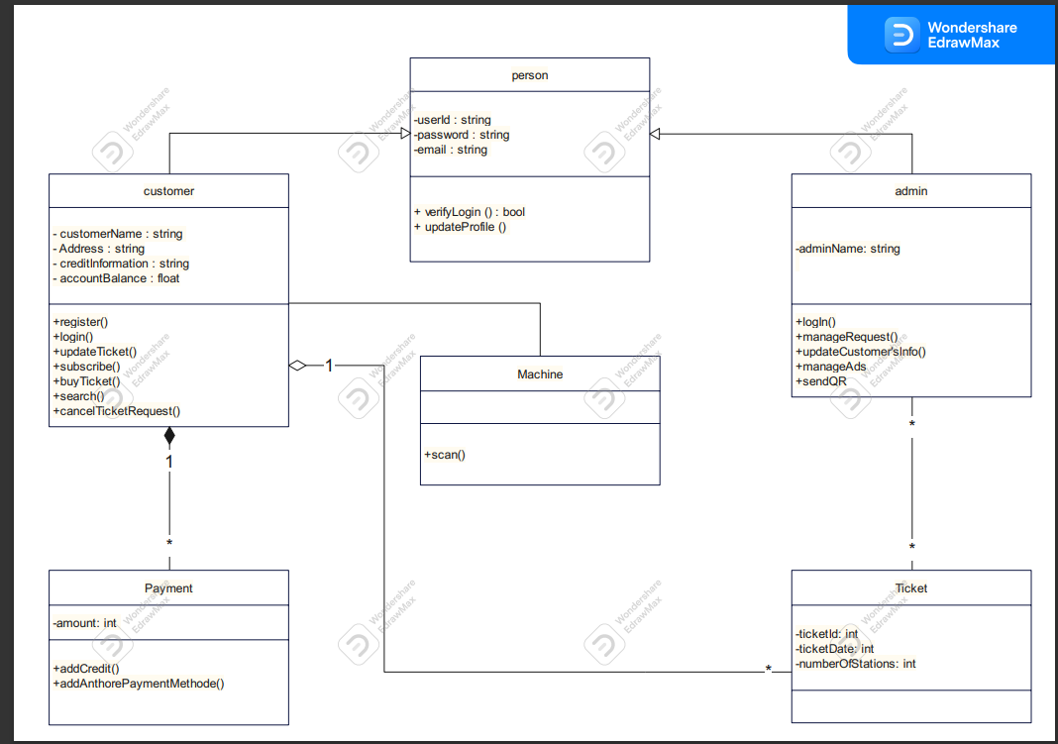

2 - Activity Diagram :

2.1 - Buy Ticket

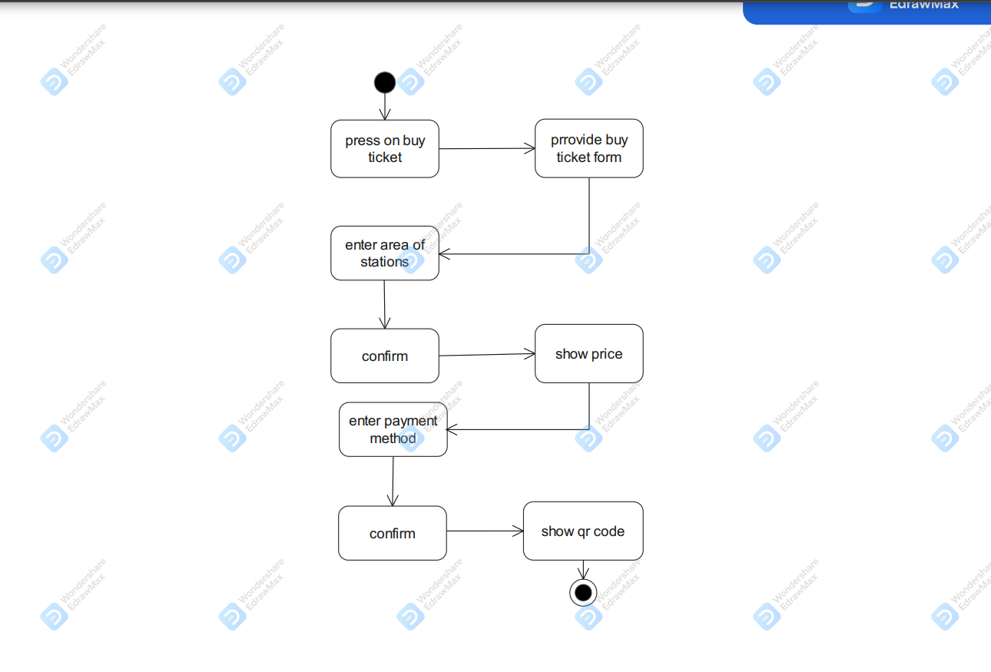

2.2 - Subscribe

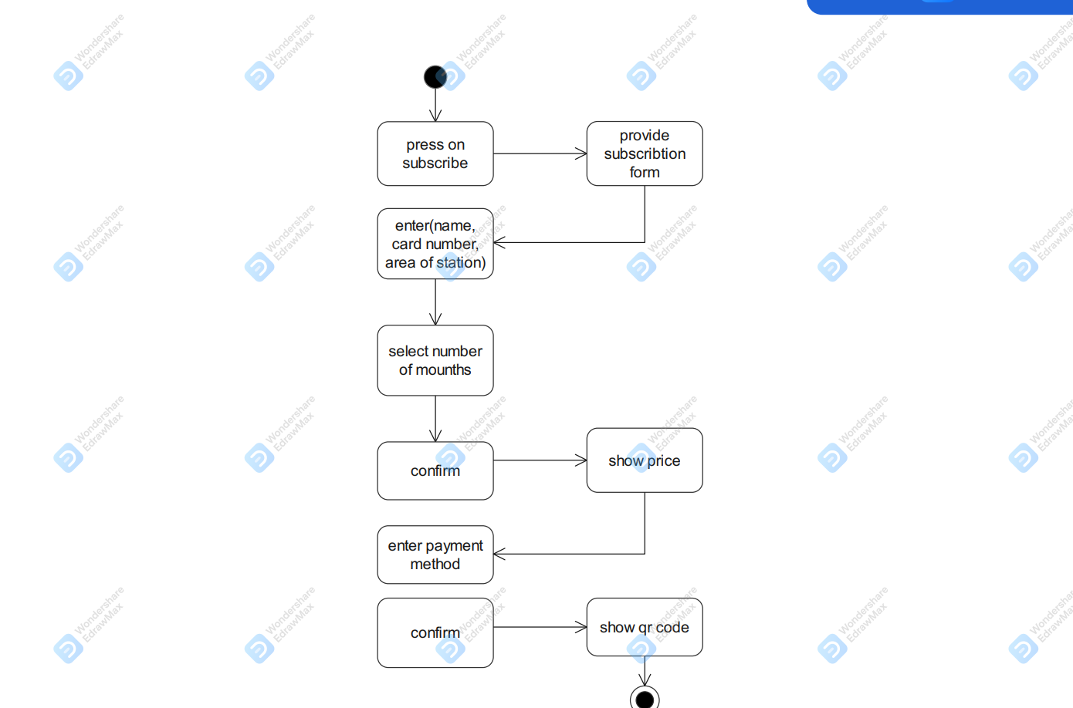

2.3 - Add Ads

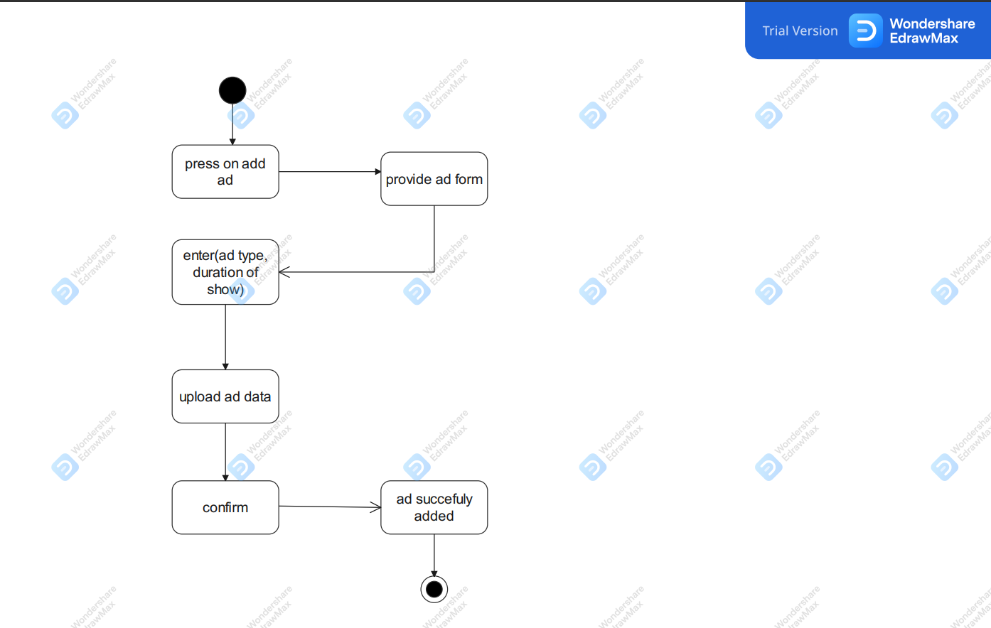

2.4 - Admin

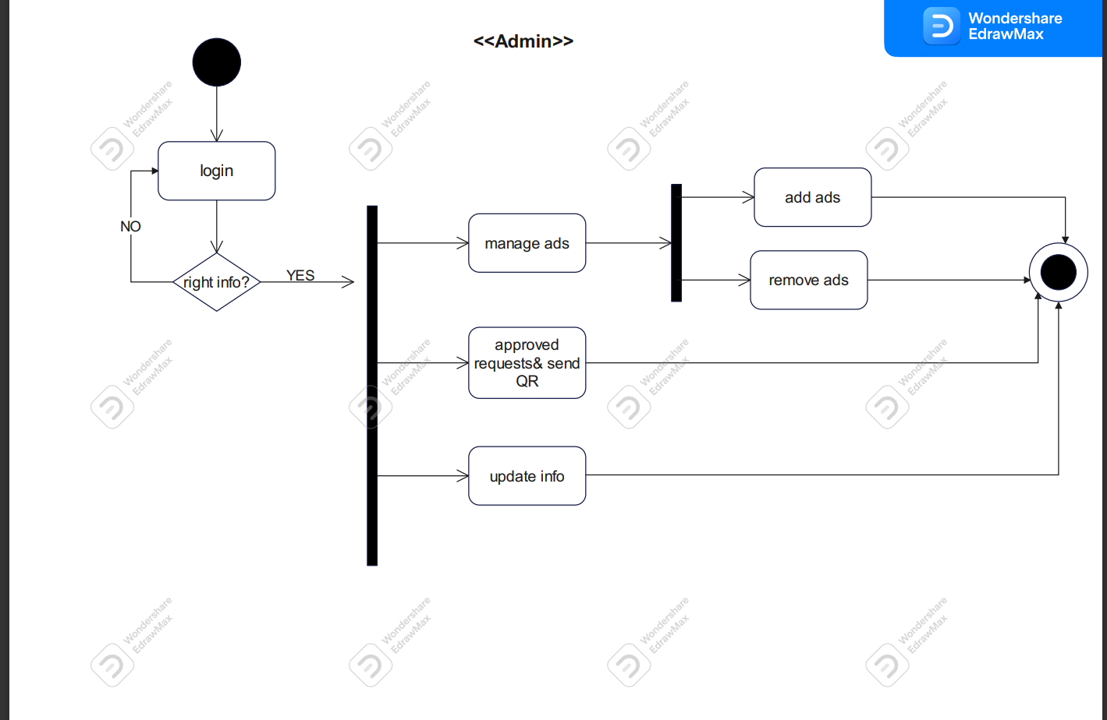

2.5- Customer

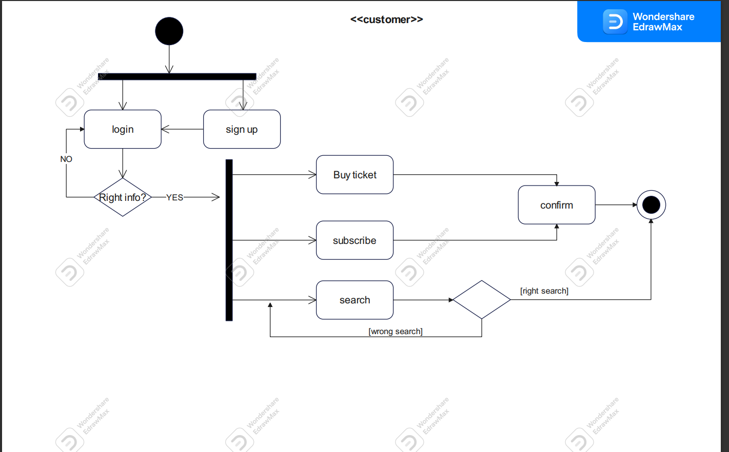

2.6 - Log in

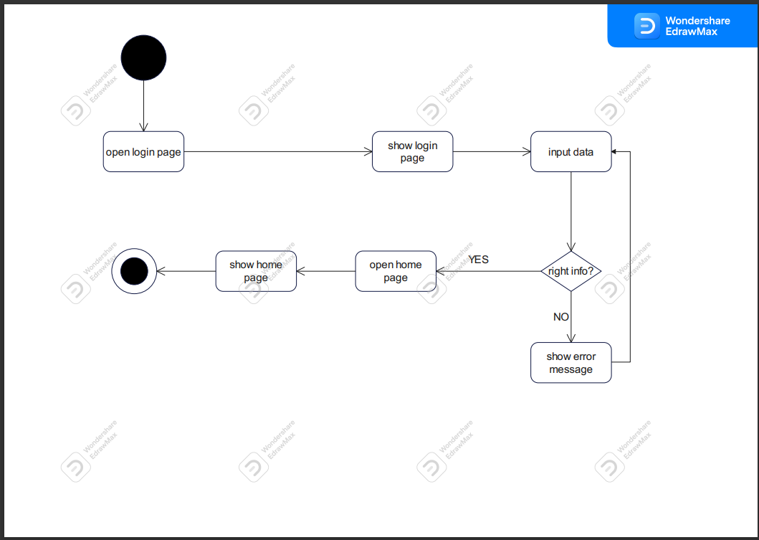

2.7 -Remove Ad

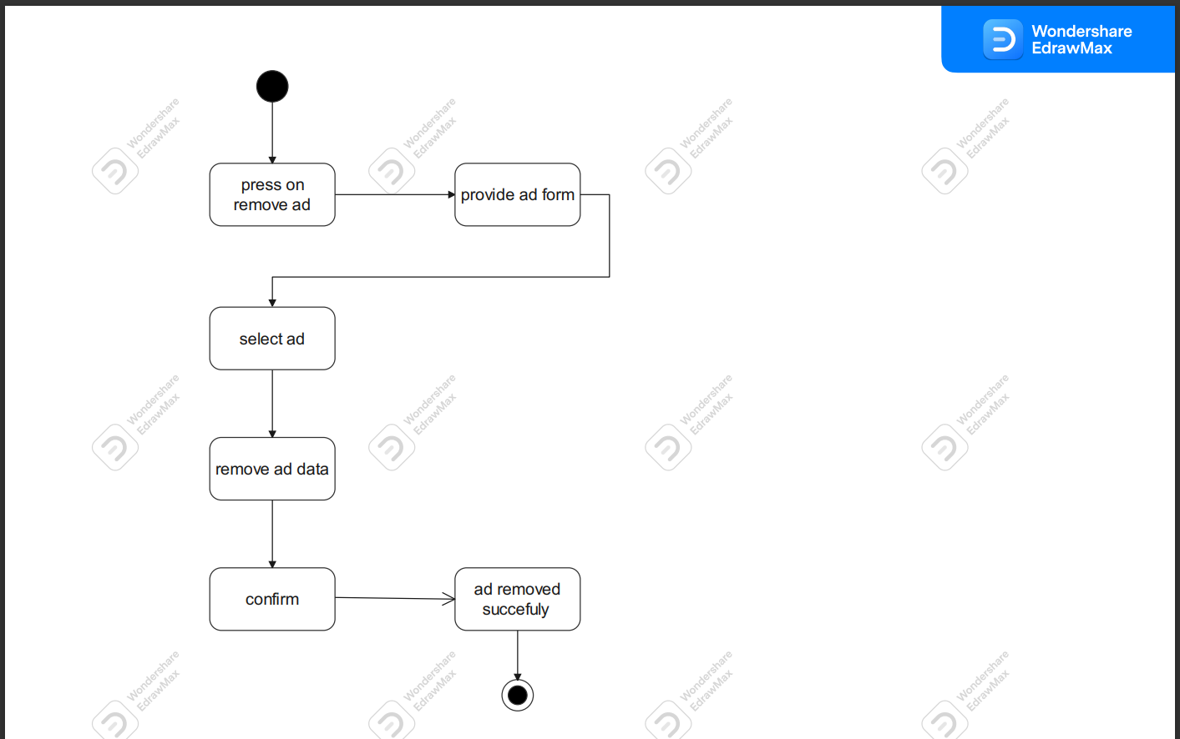

3 - sequence diagram :

3.1 -Buy Ticket

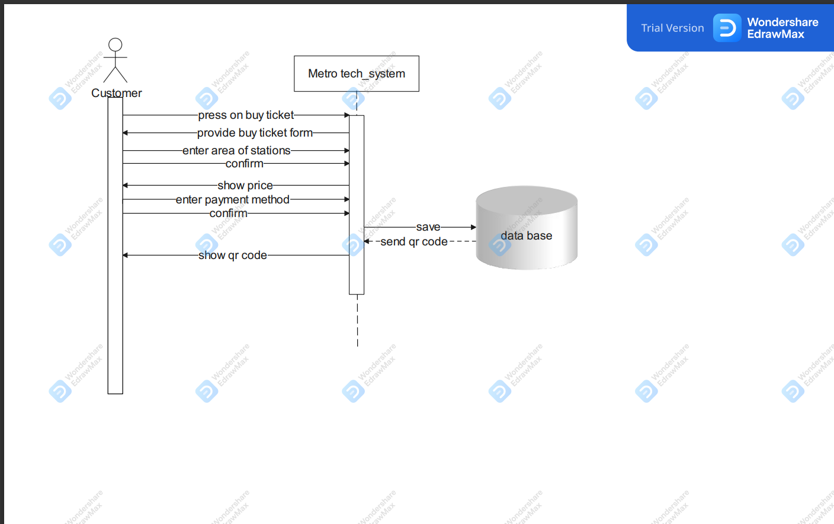

3.2 - subscribe

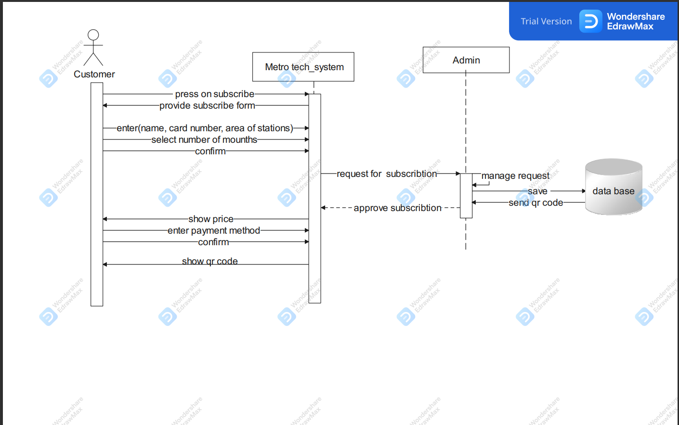

3.3 - Add Ads

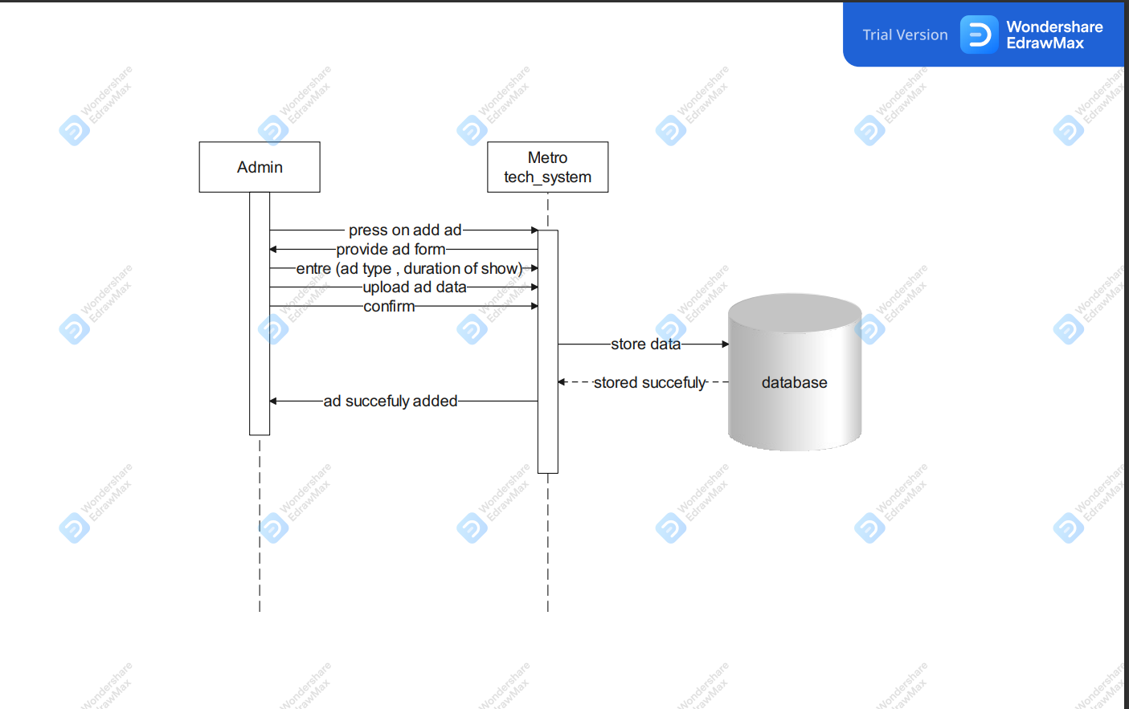

3.4 -Log in

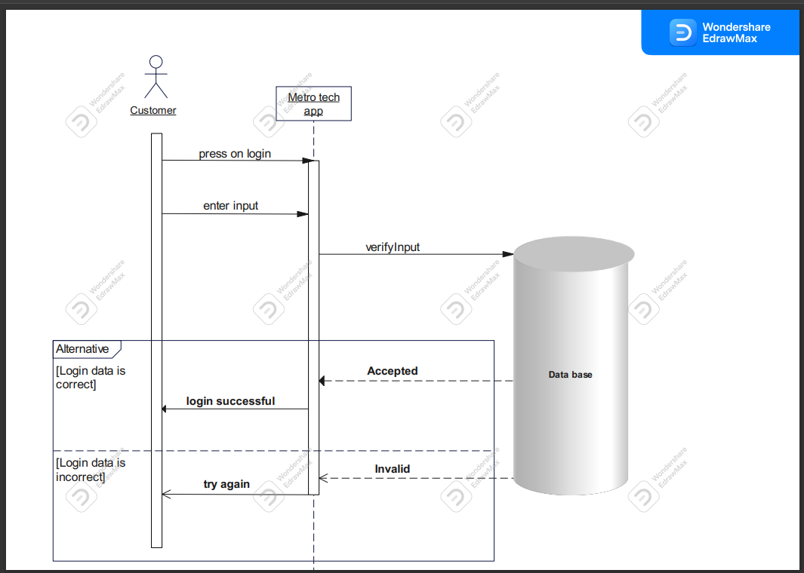

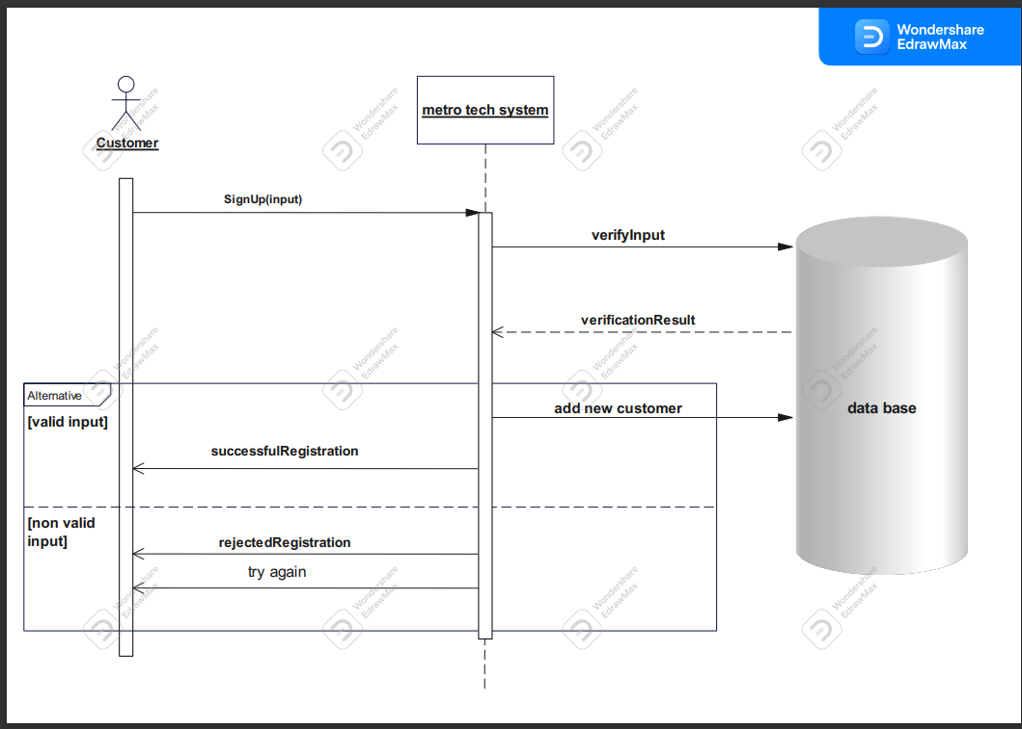3.5 - Register

3.6 - Remove Ad

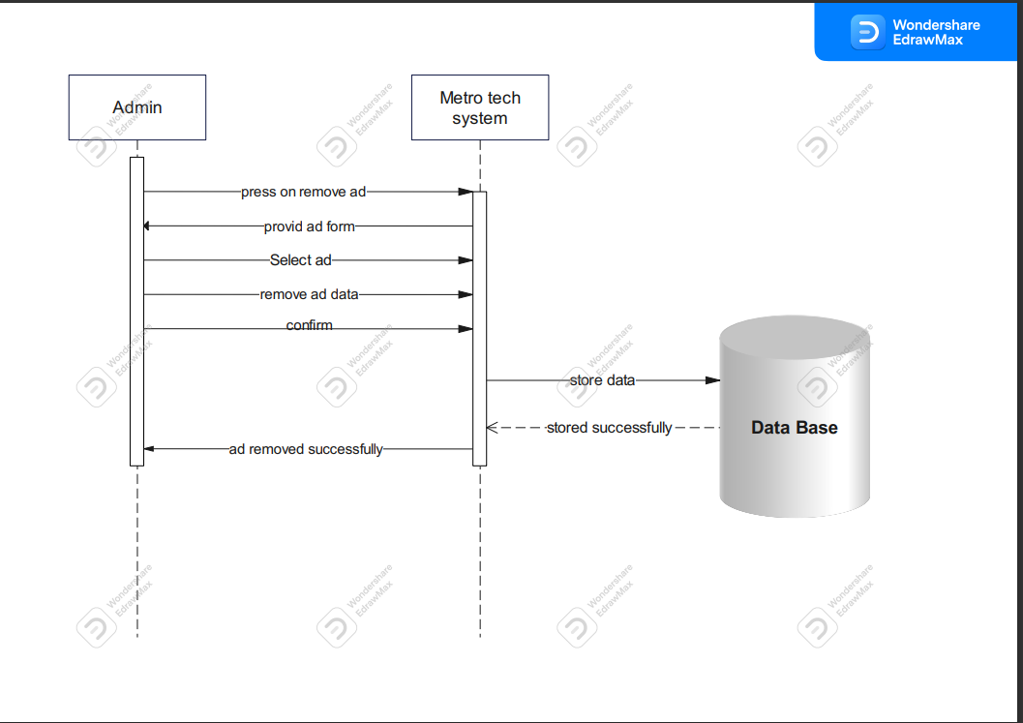

4 - Data Flow Diagram (DFD) :

4.1

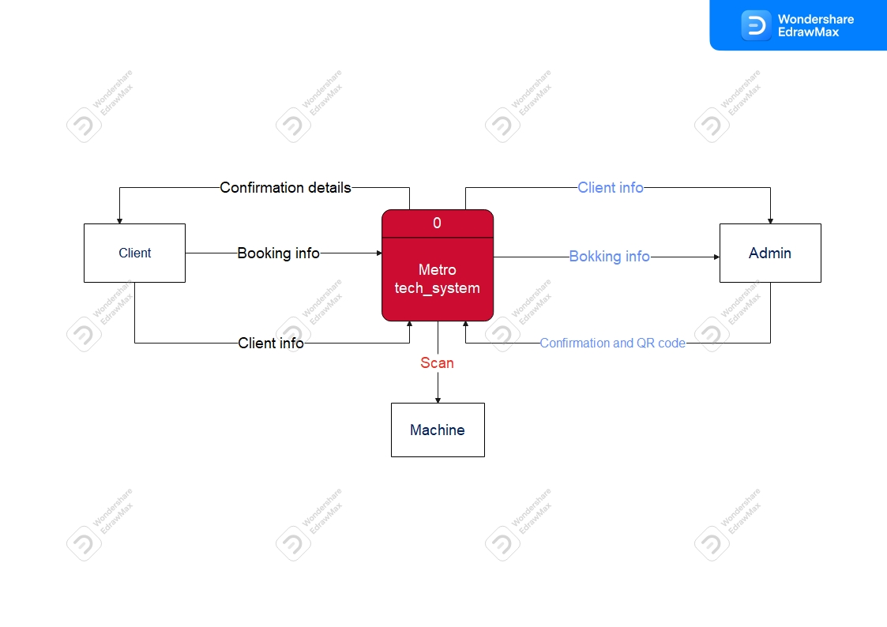

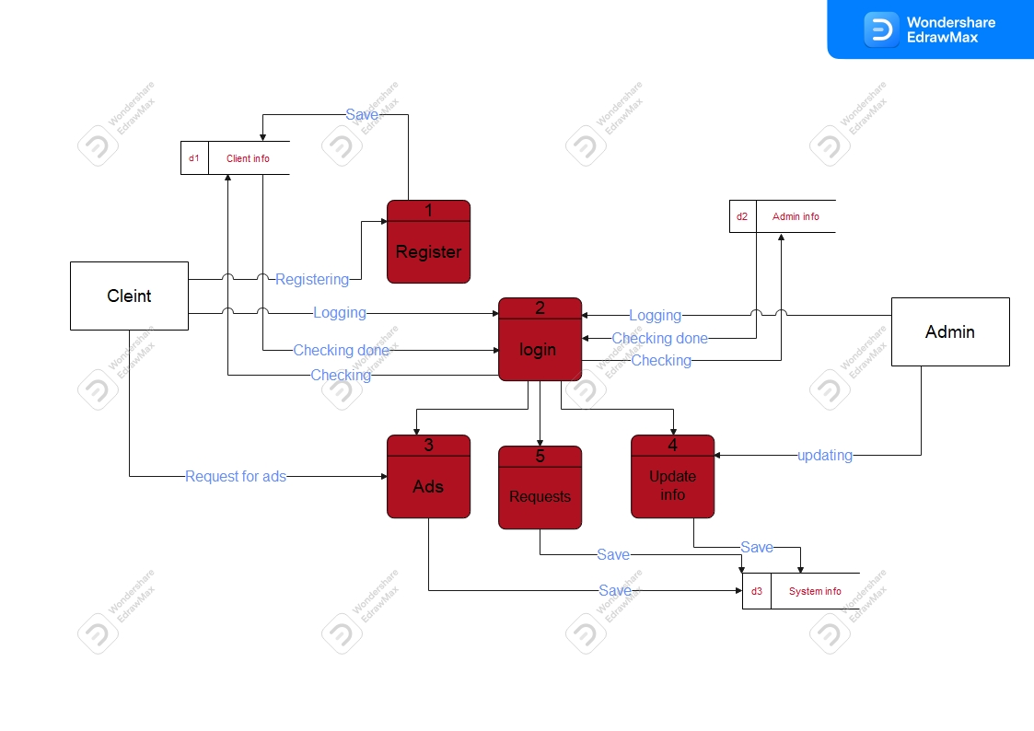4.2

4.3

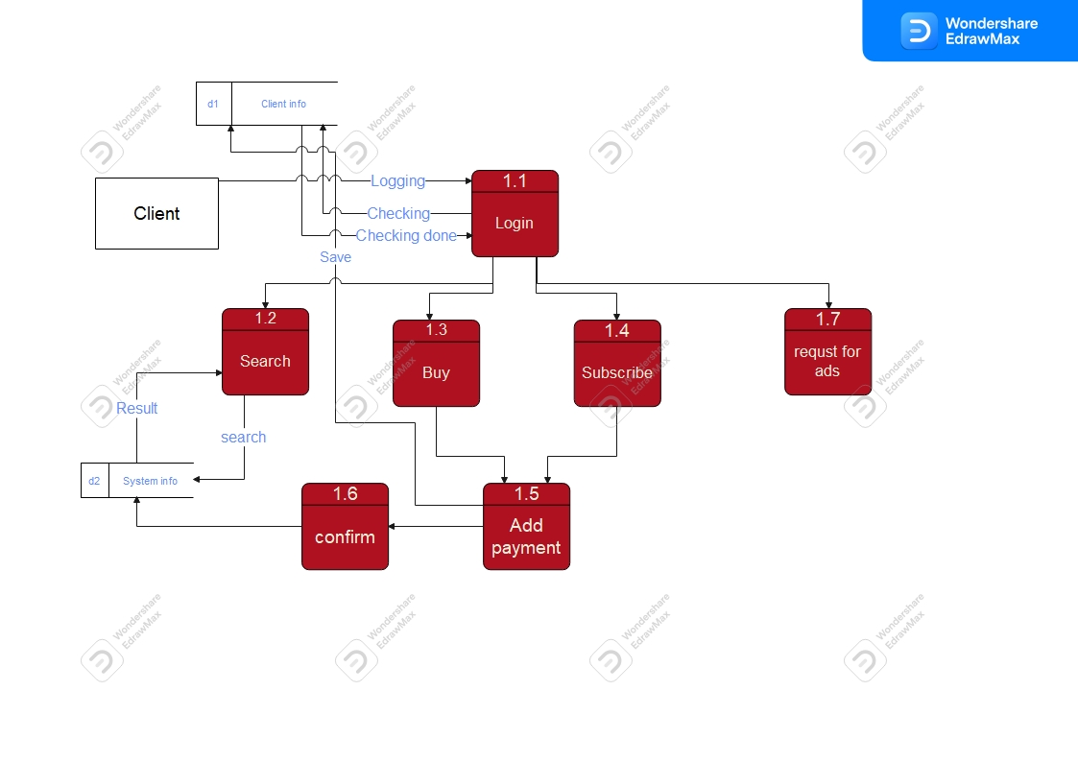

4.4

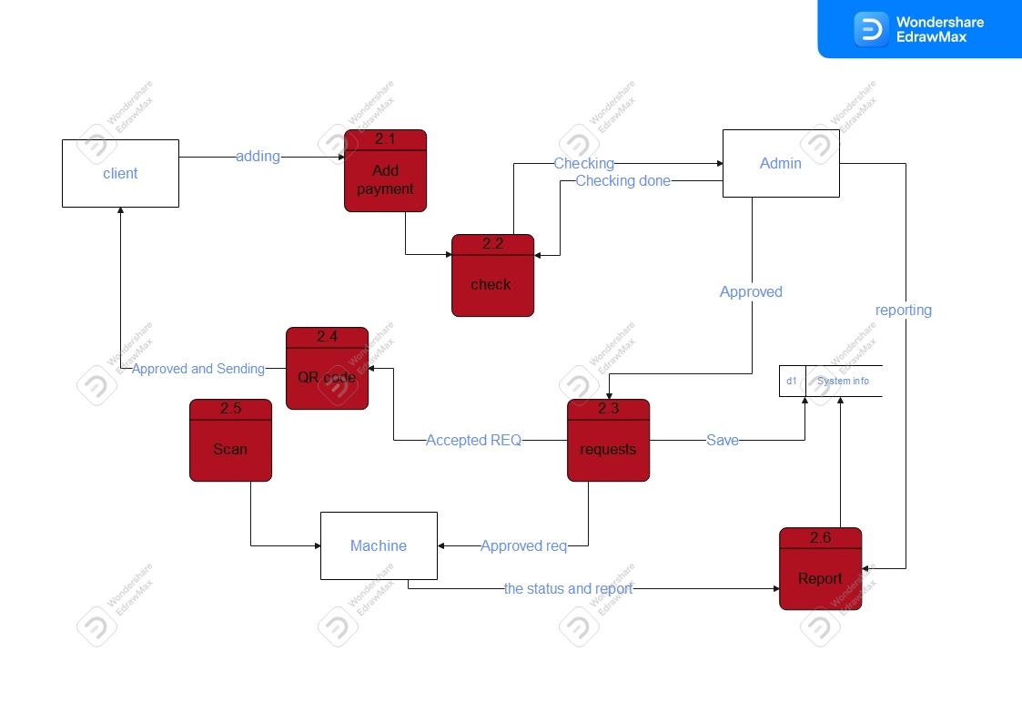

5 - use case diagram :

